**Steps to Download and Install Python 3.9 on Windows:**

**Step 1: Download Python 3.9**

To startdownload,visit  <https://www.python.org/downloads/> and then click on the button to download the latest version of Python:

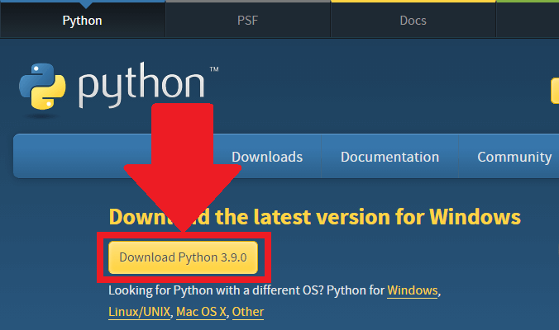

**Step 2: Run the .exe file**

Next, run the .exe file that you just downloaded:

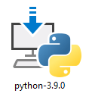

**Step 3: Install Python 3.9**

You can now start the installation of Python by clicking on **Install Now**:

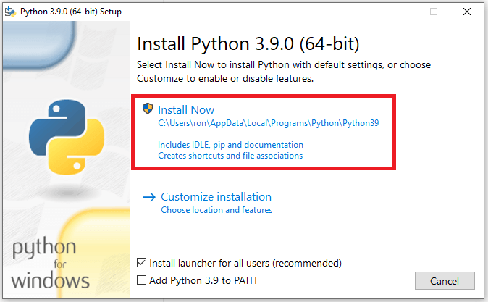

Your installation should now begin:

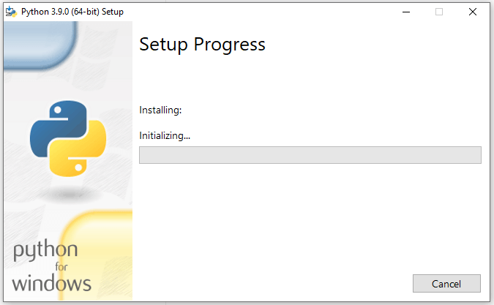

After a short period of time, your setup would be completed:

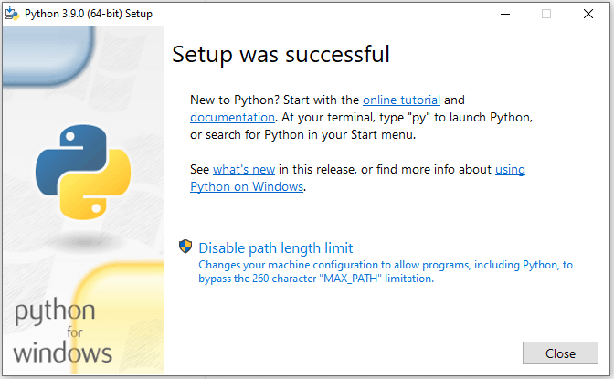

Congrats, you just installed Python on Windows!

Let’s now see how to run a simple code in Python.

**Run a Code in Python**

You can run a code in Python via the Python IDLE.

A quick way to find your Python IDLE on Windows is by clicking on the *Start* menu. You should then see the IDLE under “Recently added”

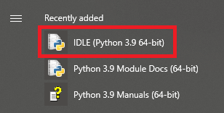

Once you click on the Python IDLE, you’ll see the Shell screen:

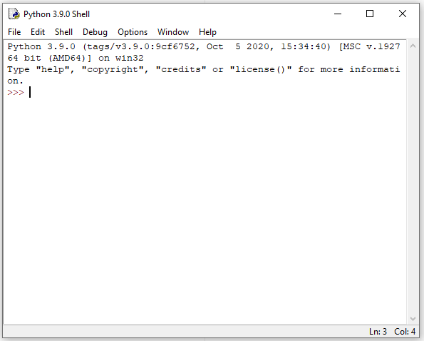

Click on **File** and then select**New File** (alternatively, you may use the keyboard shortcut of Ctrl+N):

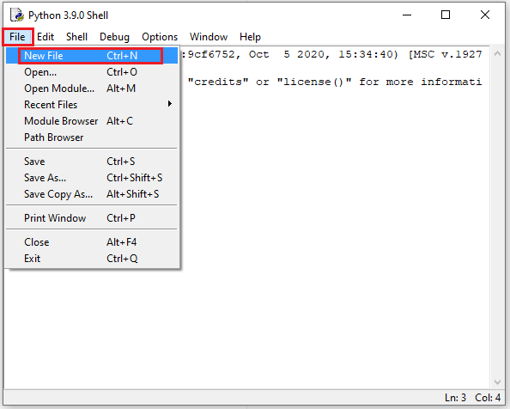

You would now see the following “untitled” box, where you can type your Python code:

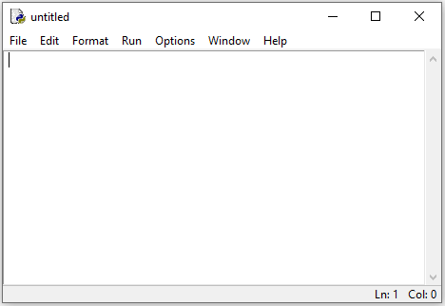

For example, type/copy the command below. This command will print the famous expression of “Hello World”

print ("Hello World")

This is how the syntax would look like in the “untitled” box:

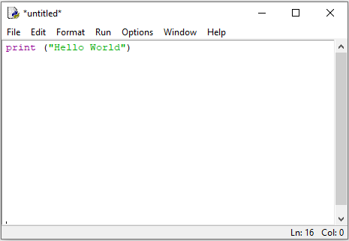

Press **F5** on your keyboard. You will then get the following message to save your code:

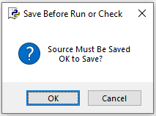

Choose a location where the Python file will be saved on your computer. You’ll also need to type a name for your file. For example, type “Test” for your file name:

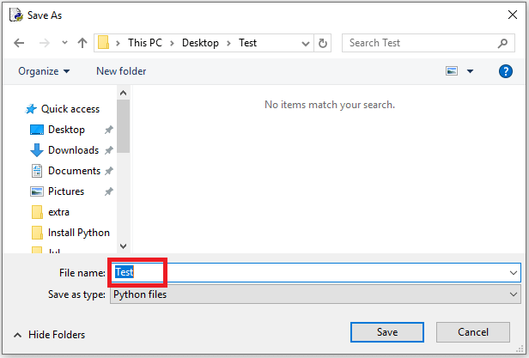

Once you’re done, press **Save,** and you’ll then see the “Hello World” expression printed on your Python Shell:

